BUG CLASSIFICATION – DICHOTOMOUS KEY DESIGN
TASK: Design and construct a dichotomous key to allow the identification of 11 different bugs.

There are a couple of important things to note about this answer scheme.
1. There is no one correct way of doing a key. There are two clear and unbreakable rules however. The first is is to use couplets (two choices) only, never use a choice of three or more options. The second is each organism has to be in a category by itself. I have followed both these rules in the example below so stand good chance of getting a good mark.
2. If you followed the two rules above, the only difference between your key and my key will be the choices for each couplet. Many of you made quite good choices, but may not have appreciated the importance of objectivity. What that means (to be objective), is to avoid choices which are subjective (duh!)… Such as the choice between big and small. Many people differ on what they think “big” is, or what “small” is. So where possible you provide a choice which makes it obvious what you mean by “big” or small”. Look at here. The choice is not long or short antennae, but “longer than legs”… so the choice is much easier to make and every person should make the same choice. Another example is here. This is not so well done on my part.
I probably should have written “front legs more than twice as
long as other legs”. But honestly I figured that was too many words!
So there is no absolutely correct way to write a choice, but try to be
as clear and objective as possible. This will be important on your
exam, if we have one at the end of the term (not sure yet what is happening).

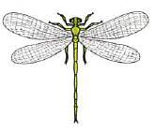
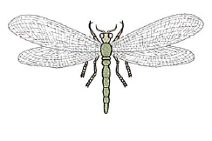
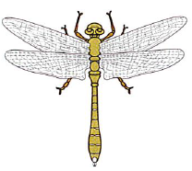
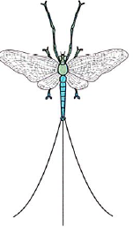
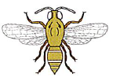
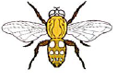
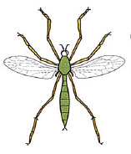
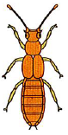
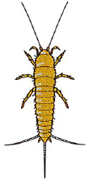
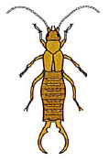
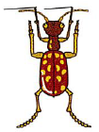
Antennae longer than legs
Dots visible on body
BUGS
Wings clearly visible
Wings not clearly visible
No dots on body
“Pincers” on abdomen
Thin appendages on abdomen
Antennae shorter than legs
One pair of wings
Two pairs of wings
Spots on Abdomen
No spots on abdomen
Wings pairs are similar in size
Wings pairs are different in size
All legs similar size
Front legs extra long
Two small antennae
No antennae
Two pairs of legs forward of wings
One pair of legs forward of wings

